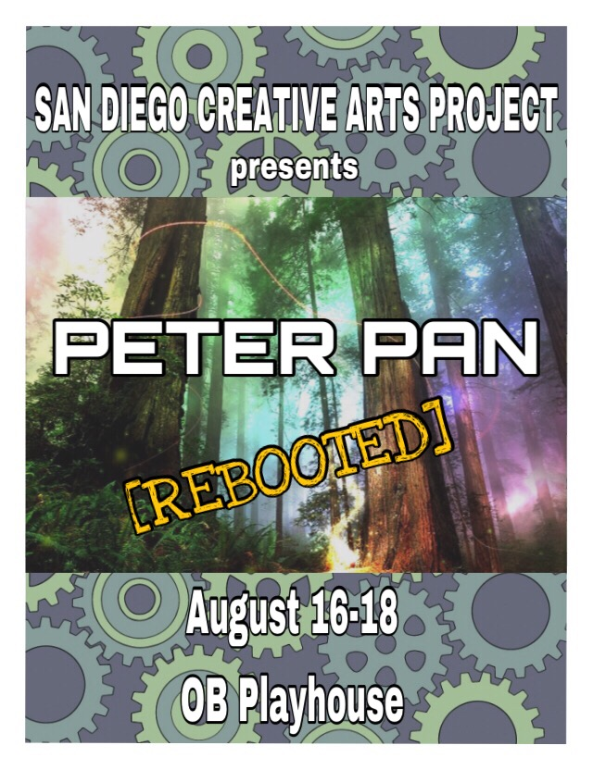



**PETER PAN REBOOTED**

**Written, Directed, and Choreographed by**

Laura Hodge

**Musical Director and Vocal Coach**

Tammy Milner

**Additional Choreography for Pirate Crew**

Mr. Dyno, of Cypherst8, SDCAP Hip Hop Teacher

**Additional Artwork, Photography, and Technical support**

Isabel Mattick

Jose Angel Mena Limonta

Bob Eisele & OB Playhouse Staff

**Director’s Note**

Peter Pan was written by by Scottish Playwrite, J.M. Barrie.

The Peter Pan character later appeared in another Barrie book,

The Little White Bird, then later appeared on stage in 1904, as “Peter Pan,

or The Boy Who wouldn’t Grow Up”.

In close study of this original story, it becomes clear that Peter Pan is a symbol

of the struggle Wendy is experiencing with adolescence.

She wants to stay young, but when she goes to Neverland, she becomes

“The Mother” to the Lost kids.

How much of Peter Pan is Wendy, and vice versa? In our production, both Peter Pan and Captain Hook are played by females. Therein lies an interesting twist, as notes of female empowerment and support comes into play. A wonderful and colorful tale of adventure, and growing up, we all are reminded to stay young at heart.



Laura A Hodge

Executive Artistic Director

San Diego Creative Arts Project

**SYNOPSIS**

All this has happened before, and it will all happen again, but this time it

happened in London. It happened in a quiet street in Bloomsbury,

at the home of the Darling family. And Peter Pan chose this particular house

because there were people here who believed in him.

We see Peter Pan lose his shadow in the Prologue, only to return seeking it.

The Darling children are loud and rowdy, and Mr Darling decides it is time

for Wendy to “grow up” and have her own room. Nana, the Nurse dog is also

put out.

Peter and Tinkerbell return to find his shadow, and Wendy wakes up to see them.

Peter tells Wendy that he can take them to Neverland where they never have

to grow up. But How? Fly of course.

In Neverland we meet the Lost Kids - who want Wendy to be their “Mother”,

Tiger Lily - the Beautiful Native American Princess- Tiger Lily, Moonglow

and her Mermaids, the Villainous Captain Hook, and his sidekick Smee,

and of course - The Crocodile.



**PRE SHOW** Thursday August 16, 7 pm & Saturday August 18, 2 pm

**Dance of the Little Swans** *Kids 3 Class*

**Twinkle Little Star** *Pre Dance*

**3** *Kids 3 Class*

**Holiday** *Pre Dance*

**Pre Dance Class:**

Mila Kuz, Ayeden RiceWilson, Luciana Berducido,

Tabitha Silva, Dagmar Ghamaty

**Kids 3 Dance:**

Kailyn Martinez, Skyelar Rice - Wilson

**PETER PAN REBOOTED MUSICAL NUMBERS**

**ACT 1**

**LOST BOY** *Wendy, Peter accompanied by Tammy Milner*

**FOREVER YOUNG**  *Wendy*

**TAKE ON ME**  *Wendy, Peter, Tinkerbell, Jean, Michelle*

**GIRLS JUST WANNA HAVE FUN** *Moonglow, Mermaids, Tiger Lily*

**BAD**  *Captain Hook & Pirate Crew*

**ACT 2**

**HAPPY***Peter and Company*

**SWEET ESCAPE** *Tinkerbell , with Moonglow, and Tiger Lily*

**IRONIC***Peter Pan*

**BELIEVE I CAN FLY** *Company*

**TAKE ON ME** Reprise *Company*

**Peter Pan Rebooted Cast List**

**Peter Pan** Cassidy Esquivel

**Tinkerbell** Tahlia Burnett

**Wendy Darling** Gabrielle Hawkins

**Jean Darling**  Leilani Coleman

**Michelle Darling/Coral**  Petra Moriset

**Mrs. Darling/Crocodile** Jayden Dial

**Mr. Darling/Smee**  Conner Llanes

**Tiger Lily** Skyelar Rice-Wilson

**Moonglow/Nana** Kailyn Martinez

**Nibs** Head Lost Kid/**Pearl** Claire Palmer

**Tootles/ Starfish** Layla Hazin

**Curly/ Anemone** Molly Palmer

**Slightly** Corbin Moriset

**Captain Hook** Isabel Mattick

**Pirate Crew**

Brayden Litkenhaus Isaac Litkenhaus

Corbin Moriset Petra Moriset



**Creative Team and Cast Bios**



**Laura Hodge San Diego Creative Arts Project** Executive Artistic Director Artist, *Writer, Producer, Director, Choreographer, Master Educator - Performer Artist* whose work is respected from Coast to Coast, and Baja Ca. Prior to **SDCAP** Laura was the Owner, Artistic Director of several award winning companies in Pittsburgh, Pa., where she trained with Pittsburgh Ballet Theatre, Point Park University, studied Theatre at the Pittsburgh Playhouse Conservatory, Carnegie Mellon University, and trained throughout NYC and LA.Laura has performed in numerous Musical Theatre productions, Dance Theatre companies, Theatrical Touring companies, Touring Companies, Film, Television, both Pittsburgh and San Diego Symphonies, is a Union Member of SAG-Screen Actor’s Guild, and does Voice Over work. Teaching, Directing, and producing credits include: San Diego Arts 4 Learning, Southwestern College, CEART Playas de Rosarito, Point Park University, University of Pittsburgh, Millenium (L.A.), Malashock Dance, San Diego Junior Theatre, San Diego Civic Youth Ballet, Mary Murphy’s (“So You Think You Can Dance”) Champion Ballroom, and private coaching throughout. As a Director, Choreographer, and Producer,

Laura has choreographed over 25 full length dance concerts, directed and created original choreography for over 40 Musicals and Ballets, choreographed for a feature Film for star Oscar Isaac, written plays, and worked on every artistic aspect of performance production.

Laura has recently written and produced “Rebooted” versions of classic Fairy Tales and given them a modern sometimes futuristic twist. She has produced four of these productions so far, here in San Diego, and CEART Playas de Rosarito, and UABC Tijuana, Mexico, where the play was translated to Spanish.

Laura believes that a dedication to proper training, and artistic integrity while encouraging students to explore their creativity is what sets a higher standard for excellence in the Performing Arts.

**Tammy Milner** *Musical Director and Voice Coach*

Tammy Milner was born in Cincinnati where she graduated from Marian H. S., and attended University of Cincinnati - College Conservatory of Music , where she majored in Opera and piano composition. As a Jazz singer and pianist she toured, did studio work with Bootsy Collins, Corporate Events, sang National Anthem for Tony Gwynn Day, and was certified in working with children with special needs through music and movement after attending Palomar College. Tammy has had her own recording studio - TJ dreams studio. Tammy has been a Minister of music for several churches, and most recently St. Paul United Methodist, where she works with several youth groups as musical director. With her own band, she wrote original songs, under the stage name Lady Blue and toured the Southern Circuit. Tammy has worked as a performer and/or musical director at Purlie Playhouse in the Park, Porgy and Bess, DreamGirls, and Musical Director for SDCAP’s Aladdin Rebooted. Tammy currently teaches private voice and piano at SDCAP.

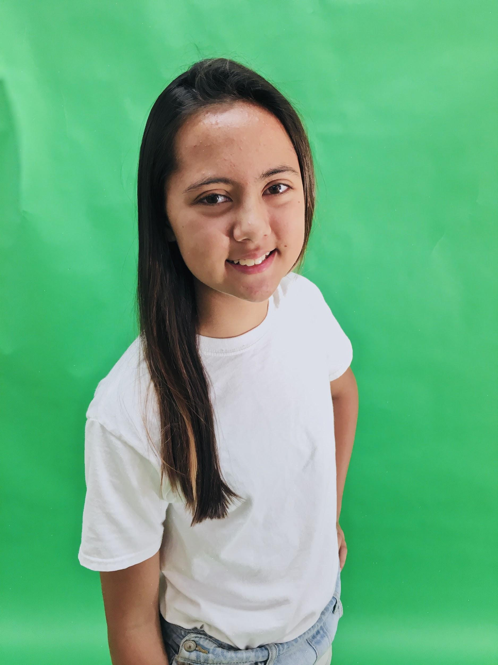

**Cassidy Esquivel** *Peter Pan*

Cassidy is currently 12 years old and enjoys acting, singing, playing

soccer, musicals and spending time with her friends. She has been in previous performances with CIT camps and classes, including

Beauty and the Beast, where she was part of the ensemble, and Off to Neverland, when she played a lost boy. Her favorite musical currently is Hamilton. This is Cassidy’s first production with SDCAP!!!



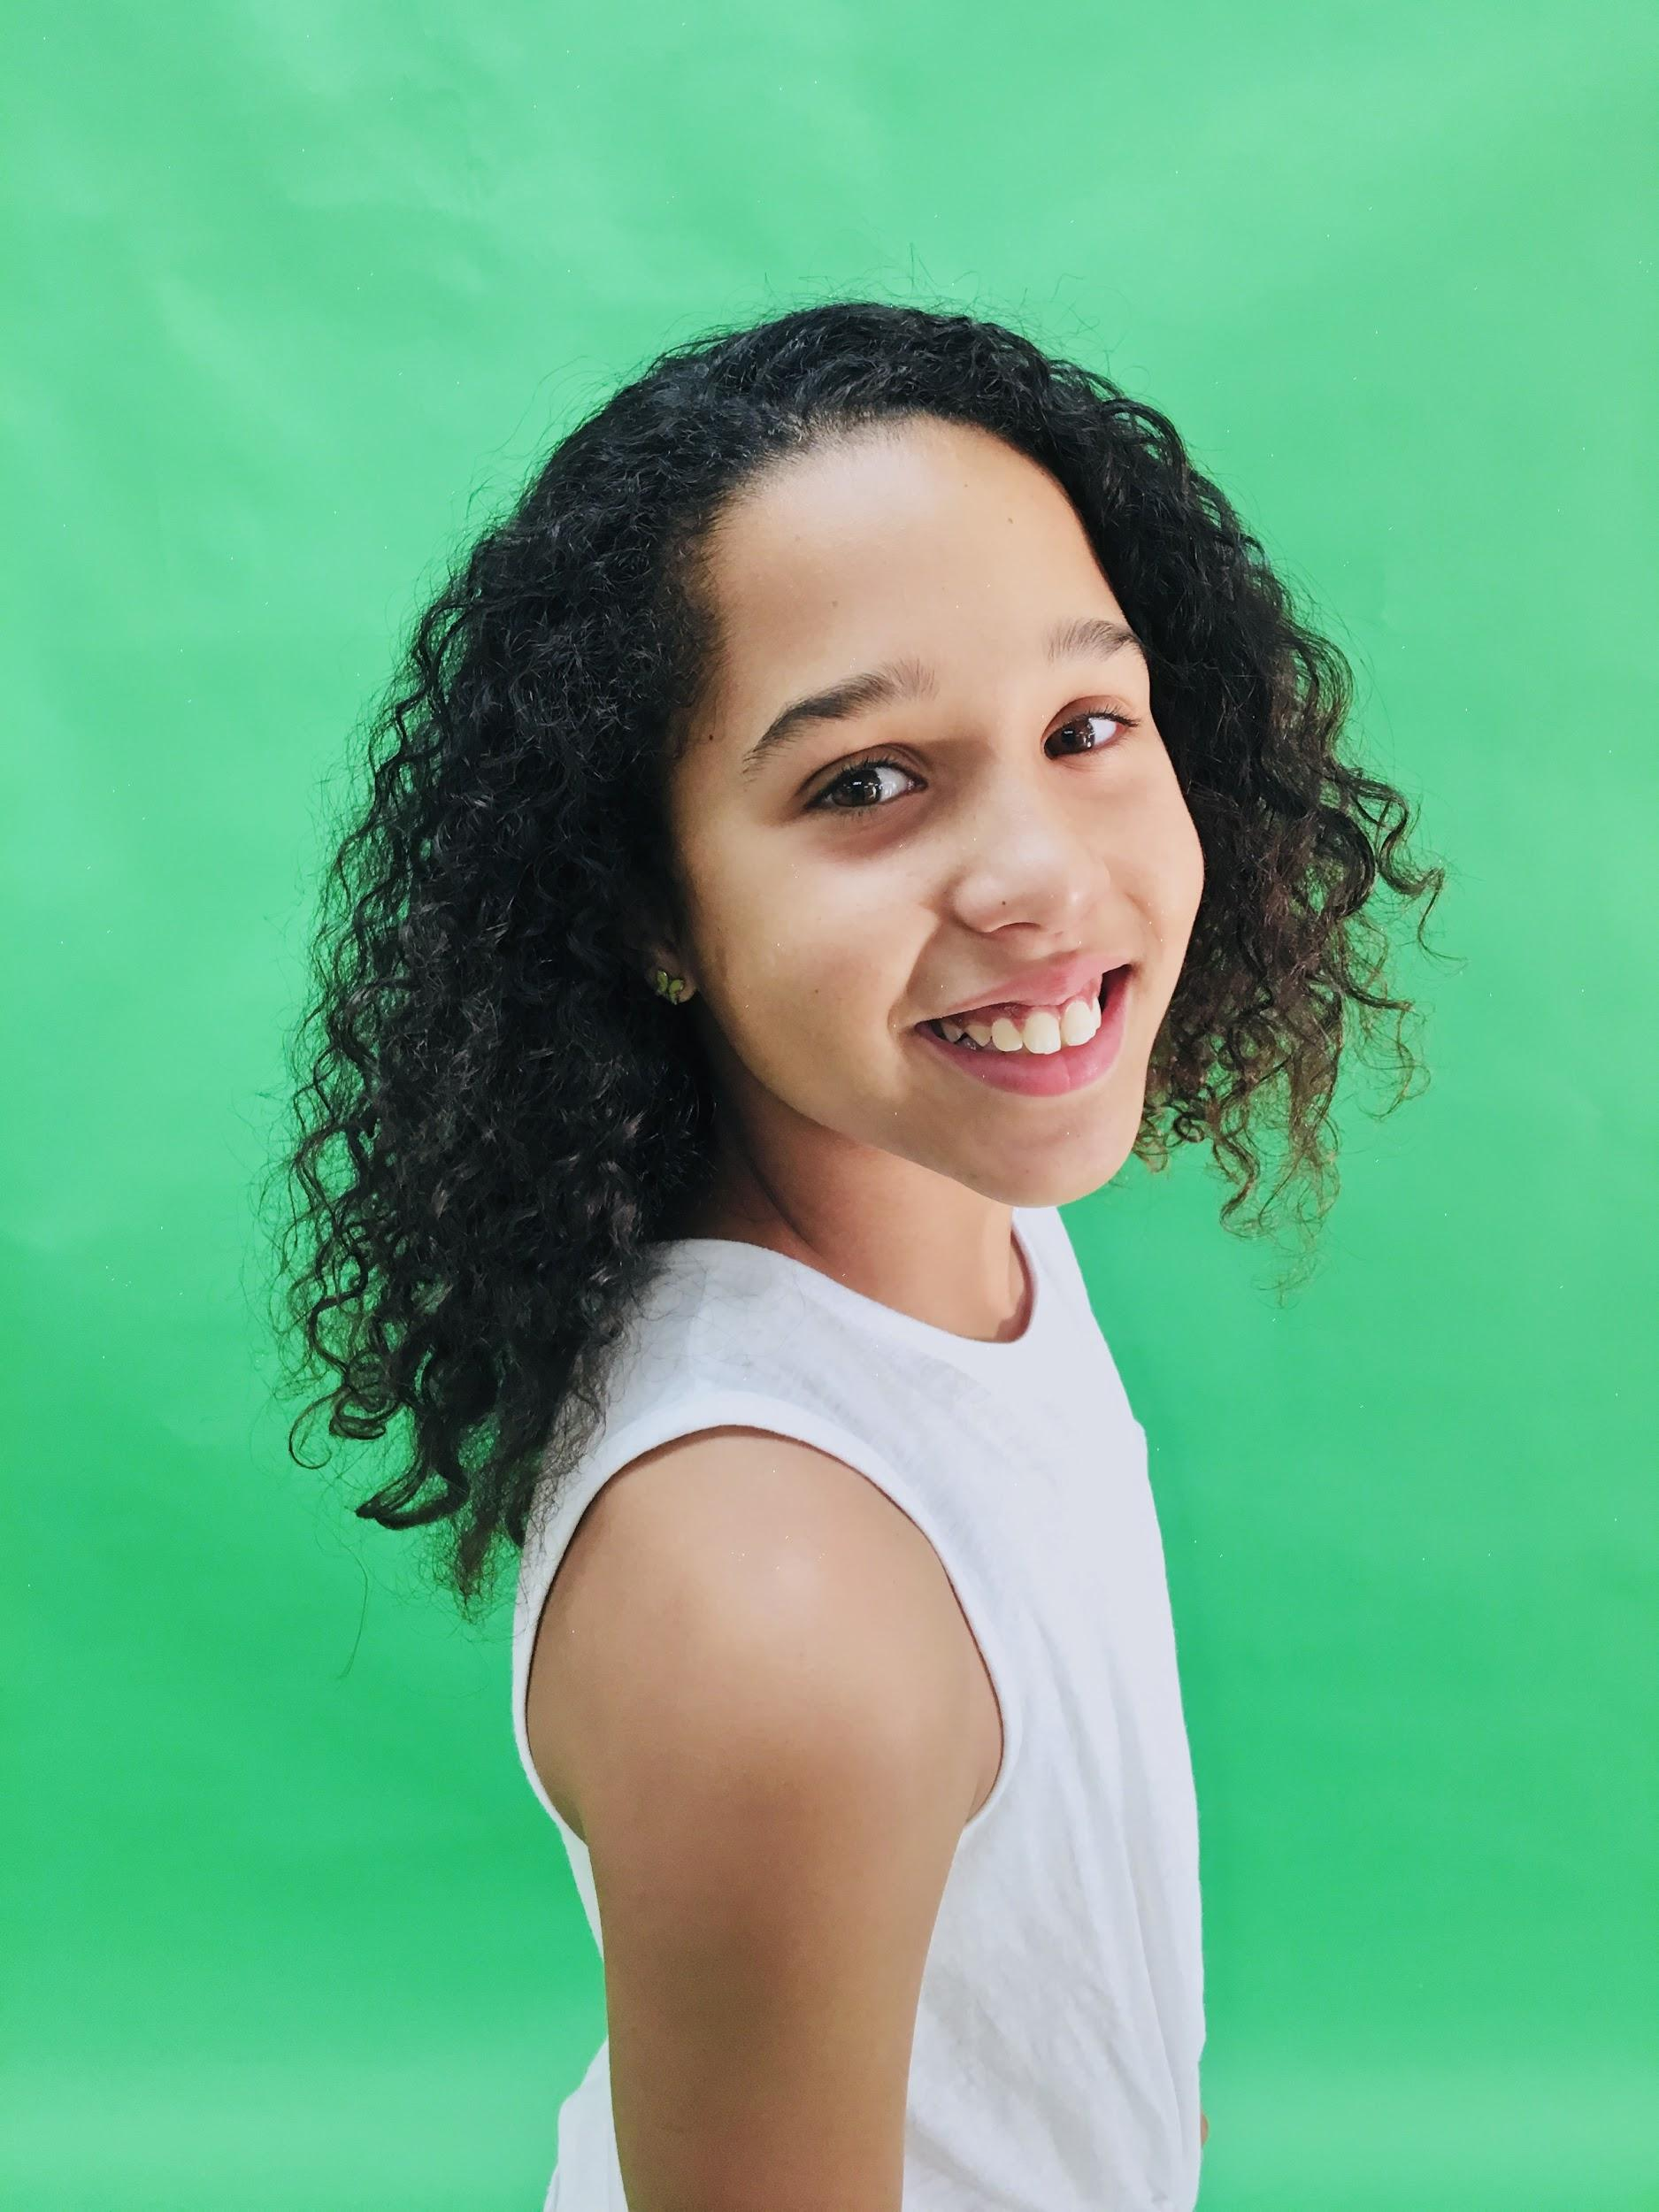

**Gabrielle “Gaby” Hawkins** *Wendy*

Gaby is 10 years old and lkes drawing, animating, creating videos and rock climbing. Her Previous Performances/Roles are with School Choir Club, Hairspray as Cindy Watkins, Alice in Wonderland- Royals Cards Men.

Her Favorite Musical is Hamilton. This is Gaby’s first performance with SDCAP!

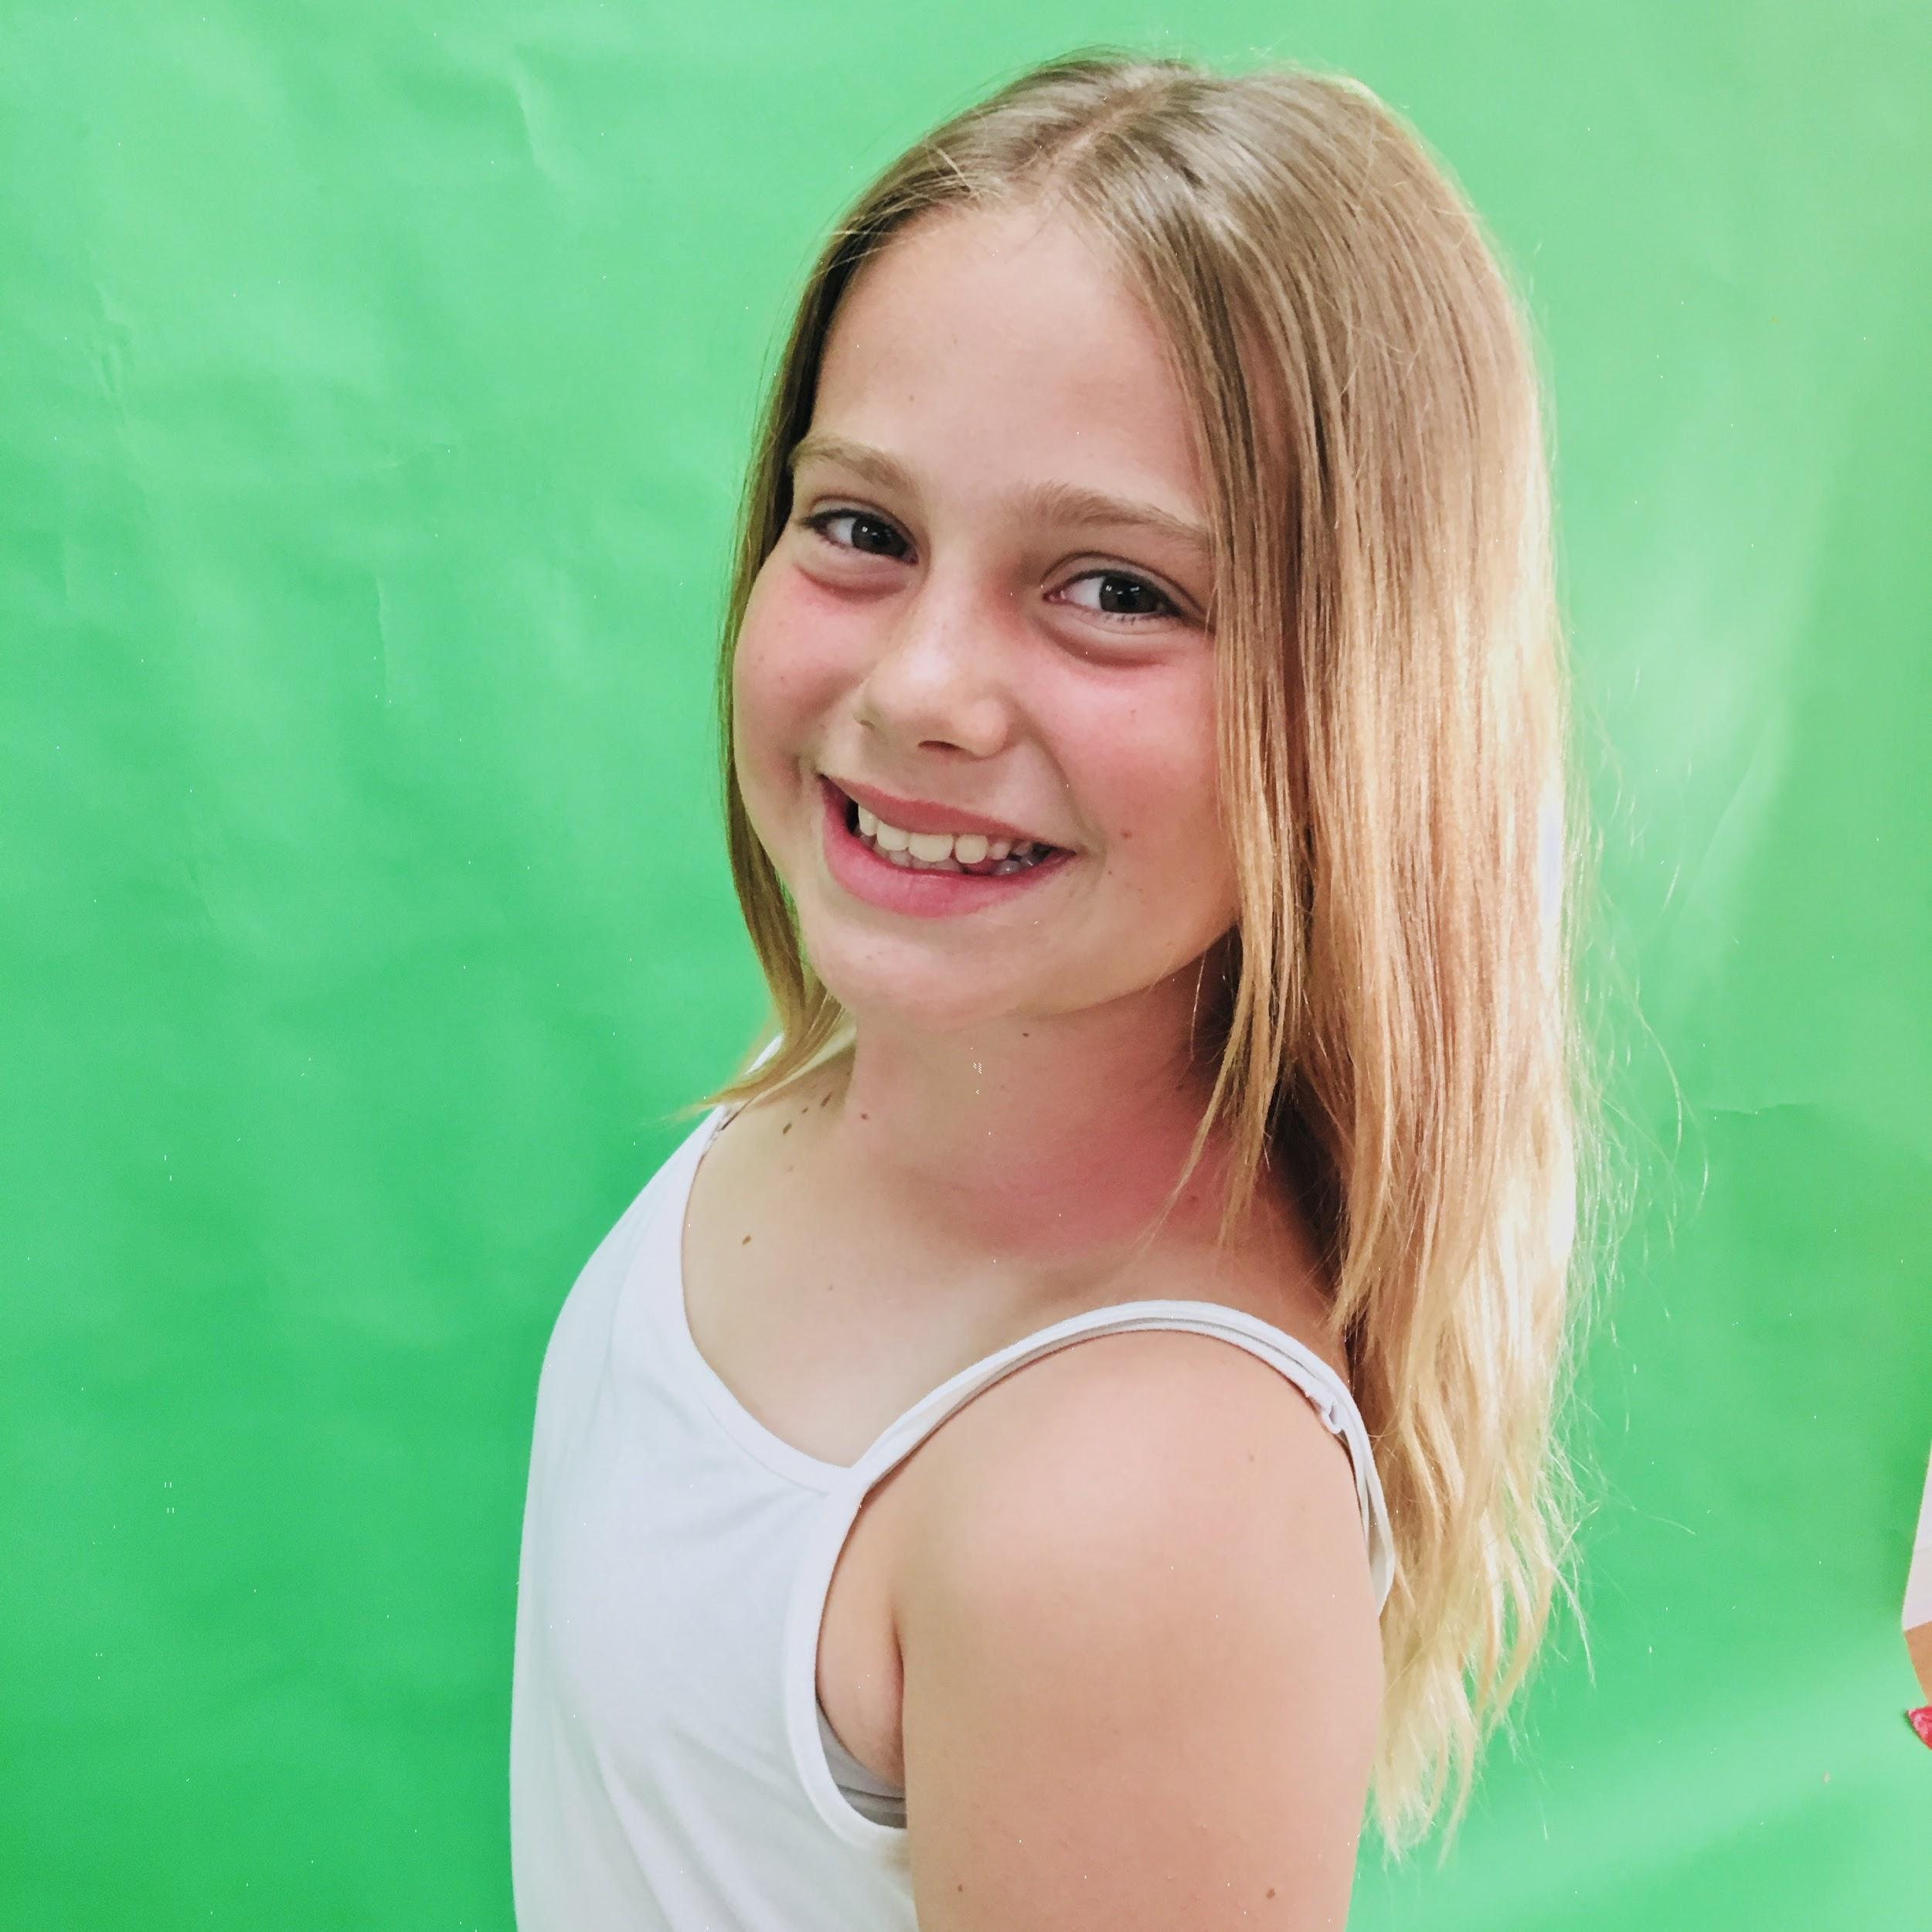

**Tahlia Burnett** *Tinkerbell*

Tahlia is 11, and is excited about playing Tinkerbell in this production. She was Bobby Jean Piper in SDJT’s Junie B. Jones (2017) and she has been performing with the Kindertanzgruppe of the German American Society of San Diego since 2013. Tahlia loves to sing, bake, play soccer, and make movies. Her favorite musical is Tuck Everlasting.

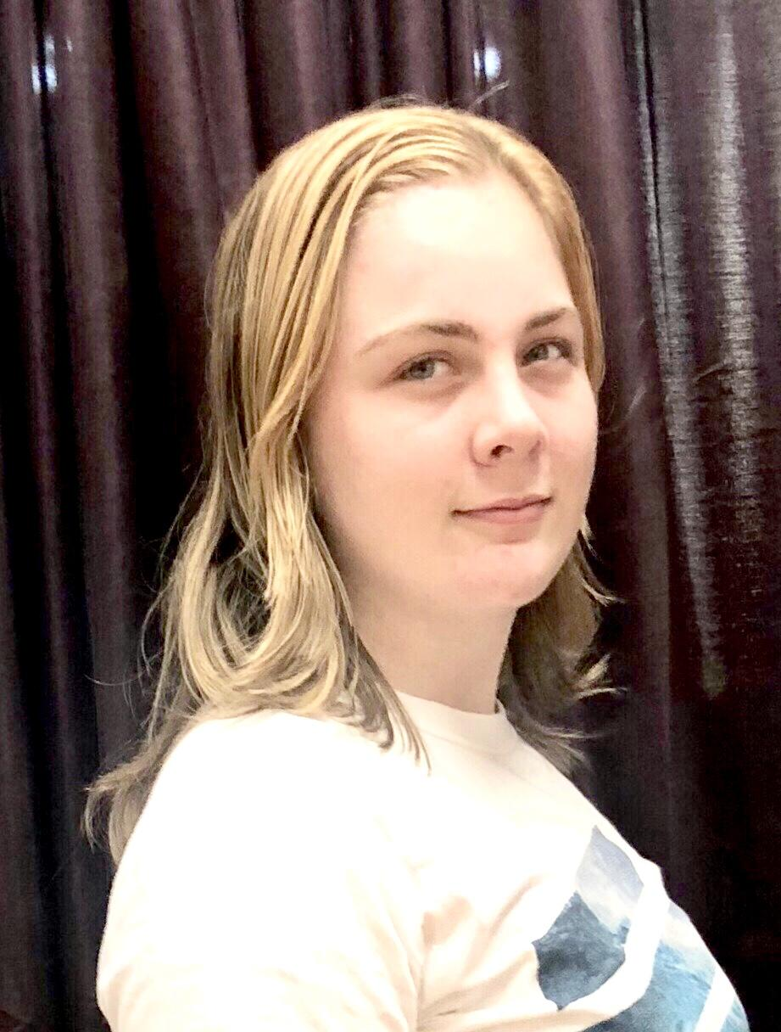

**Isabel Mattick** *Captain Hook*

Izze is 15 years old, and going to be a sophomore at San Diego High. Izze has been involved in Musical Theatre and Dance since she was 3. Some of the shows she has performed in with her Mom, Laura, have been CATS as Mungojerrie, and SDCAP shows, Christmas Carol in old SD- Marley’s Ghost, Seussical, Beauty and the Beast, Wizard of Oz -Cowardly Lion, Godspell, Fame, Cinderella Rebooted, Cenicienta, and Aladdin Rebooted. When not onstage, Izze likes to do graphic design, and resin casting, and she loves and collects Furbys.

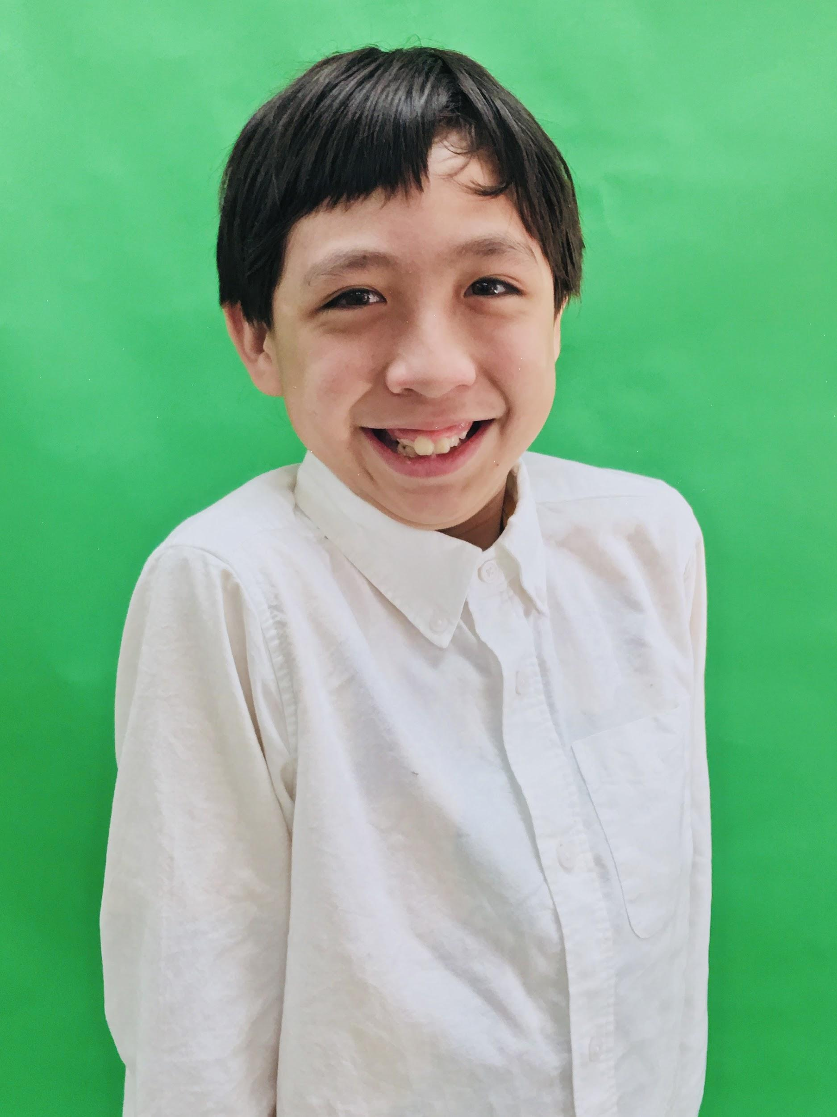

**Conner Llanes** *Smee, Mr. Darling*

Conner is 12 years old. He has done runways, a commercial, and has been an extra in a web movie series. He hobbies include drawing and performing arts. He loves to showcase his talents.

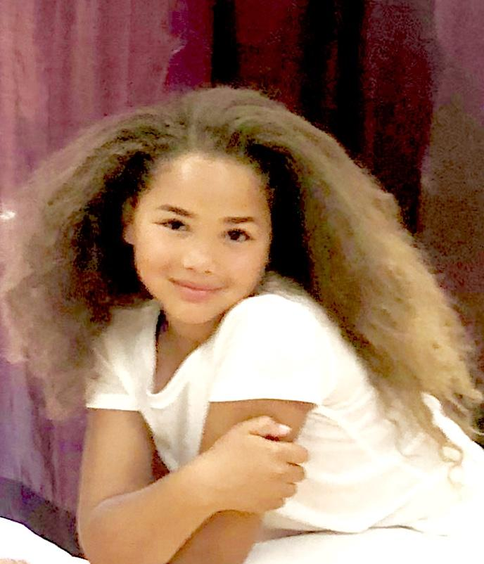

**Leilani Coleman** *Jean Darling*

Age 8 Likes/hobbies: softball, dance This is her 1st

musical. She has worked on Commercials, TV series, and music videos. This is Lealani’ s first SDCAP production.

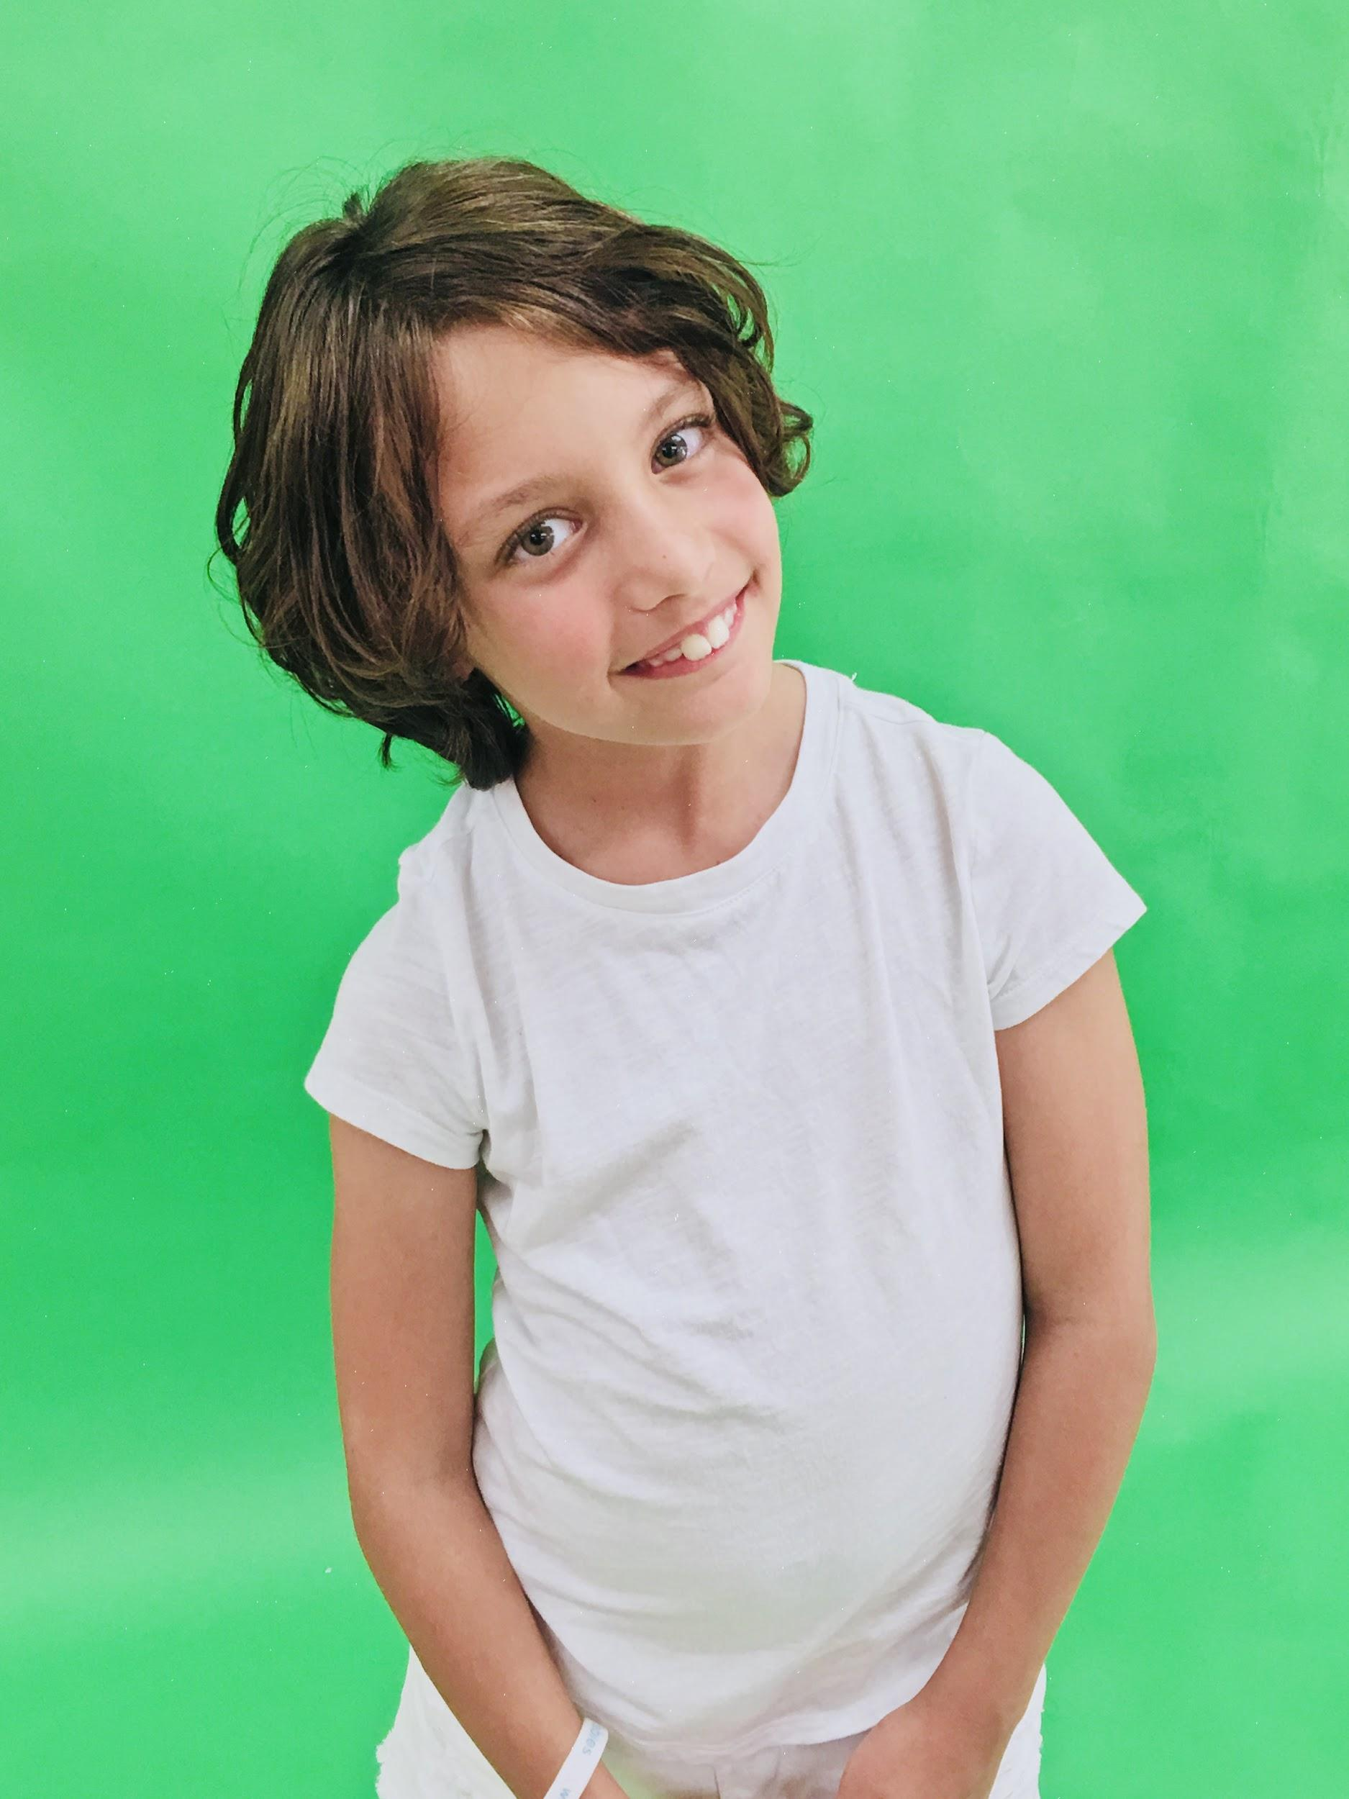

**Petra Moriset** *Michelle Darling, Coral, Pirate Crew*

Petra is 8 years old. She's a sweet, kind, loving little lady. Petra loves dancing, skating, and anything artsy. Petra loves acting and singing and this will be her

second show with SDCAP.

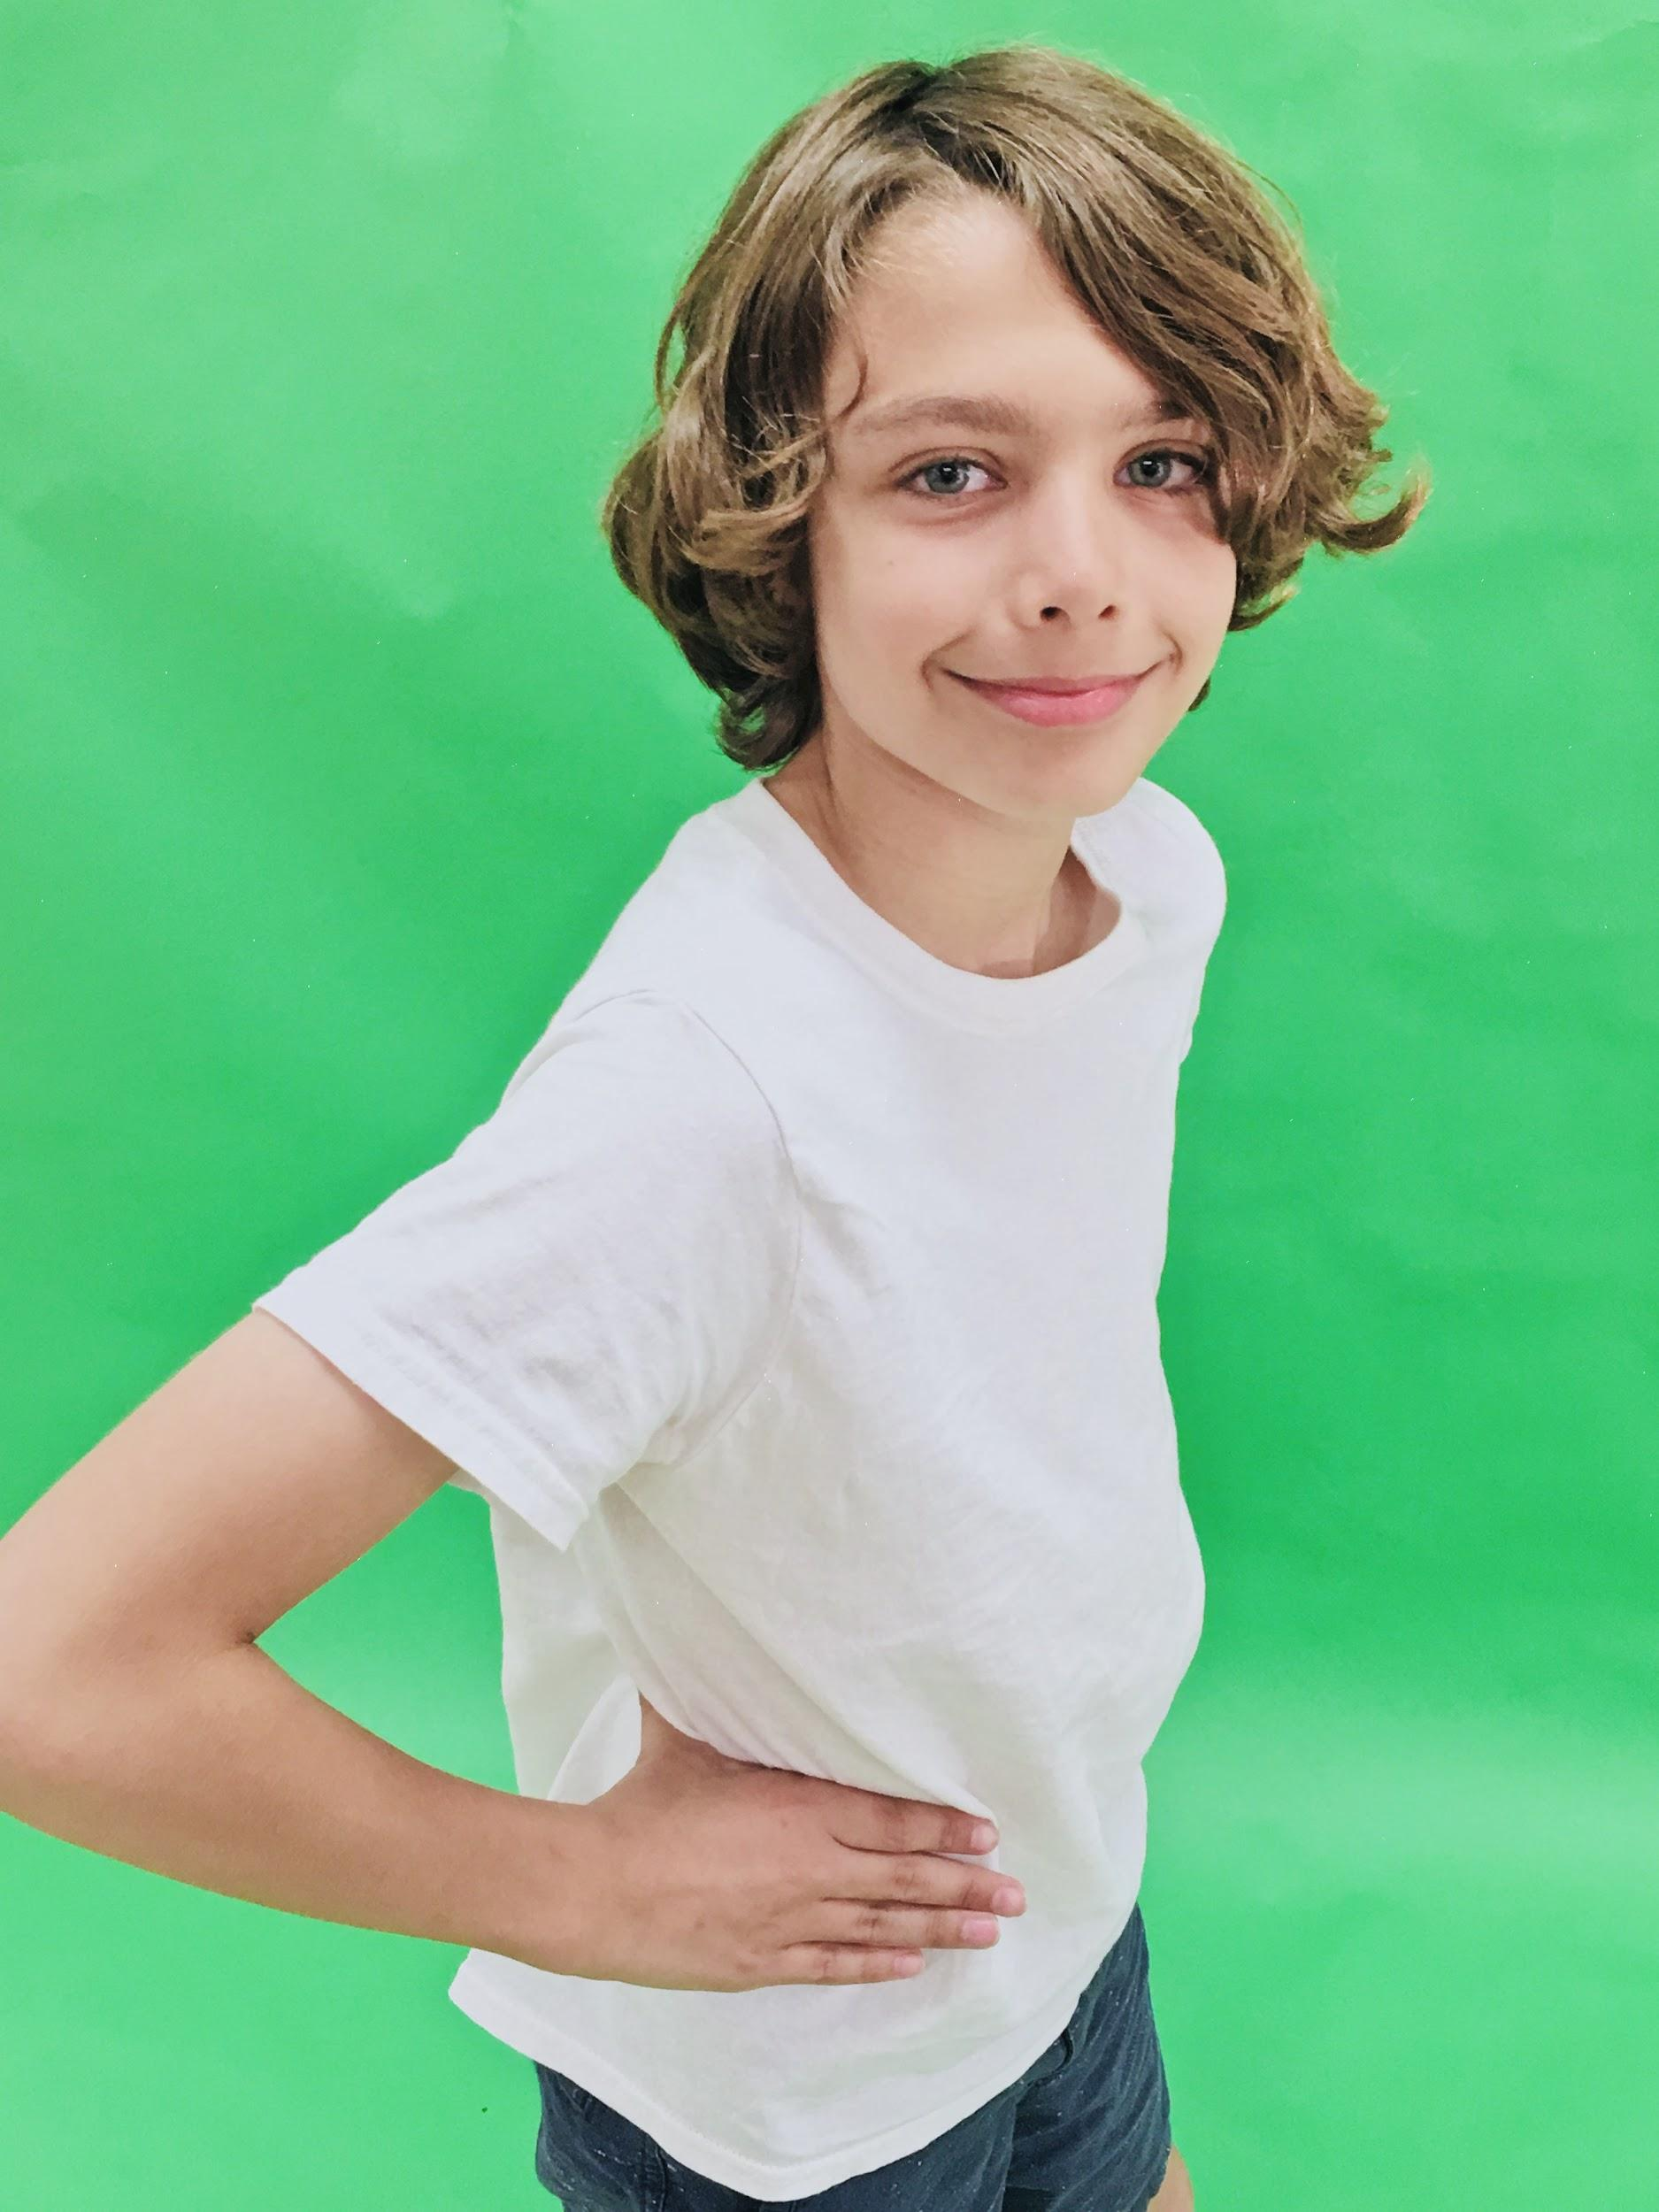

**Corbin Moriset** *Slightly, Pirate Crew*  is 11 years old. He's a sweet, funny, witty young man. Corbin is really into cars, gaming, soccer and he loves doing Hip Hop at SDCAP. This is his first play with Ms Laura and SDCAP.

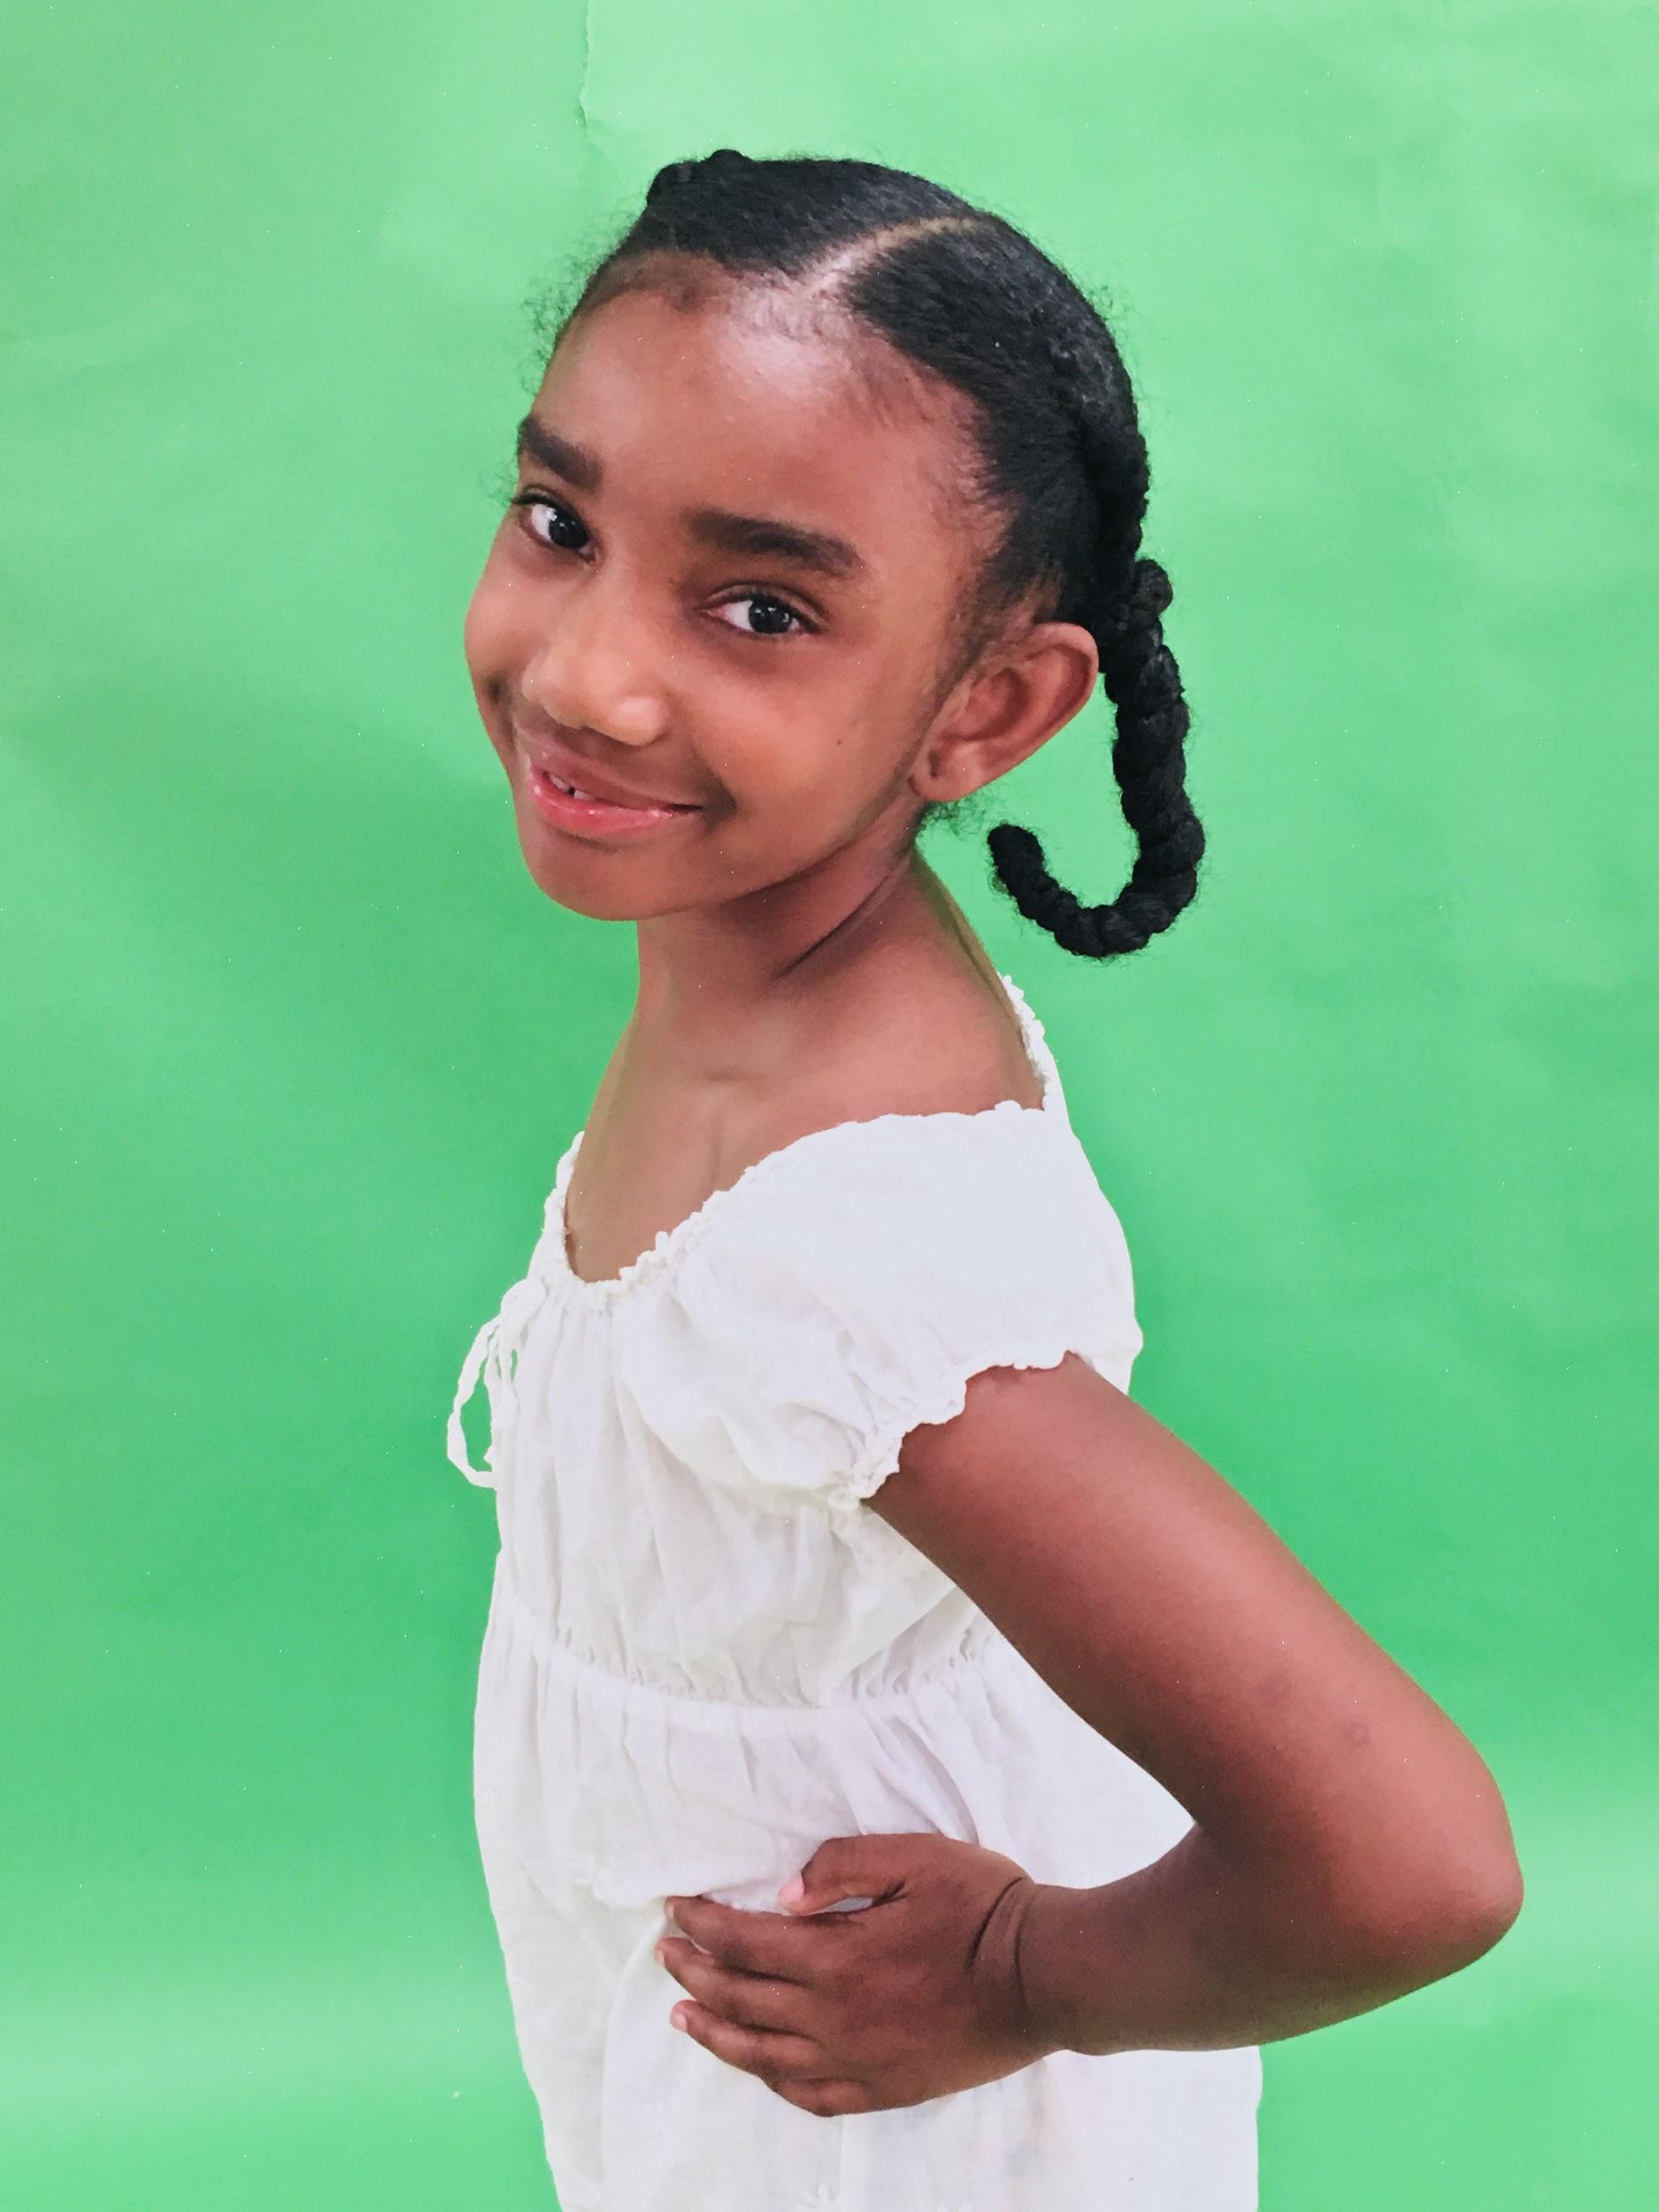

**Skyelar Rice Wilson** *Tiger Lily*

Skyelar is a bright and budding actress who loves to sing and dance. She has been participating in SDCAP productions and classes since she was 4, this is her 5th show with Ms. Laura. This vibrant and smart 8 year old, will be in 3rd grade.. When she grows up she wants to be a famous model. In her spare time she creates music videos, dances with her sisters. Her favorite films are Peter Rabbit and Coco.

**Kailyn Martinez**  *Nana, Moonglow*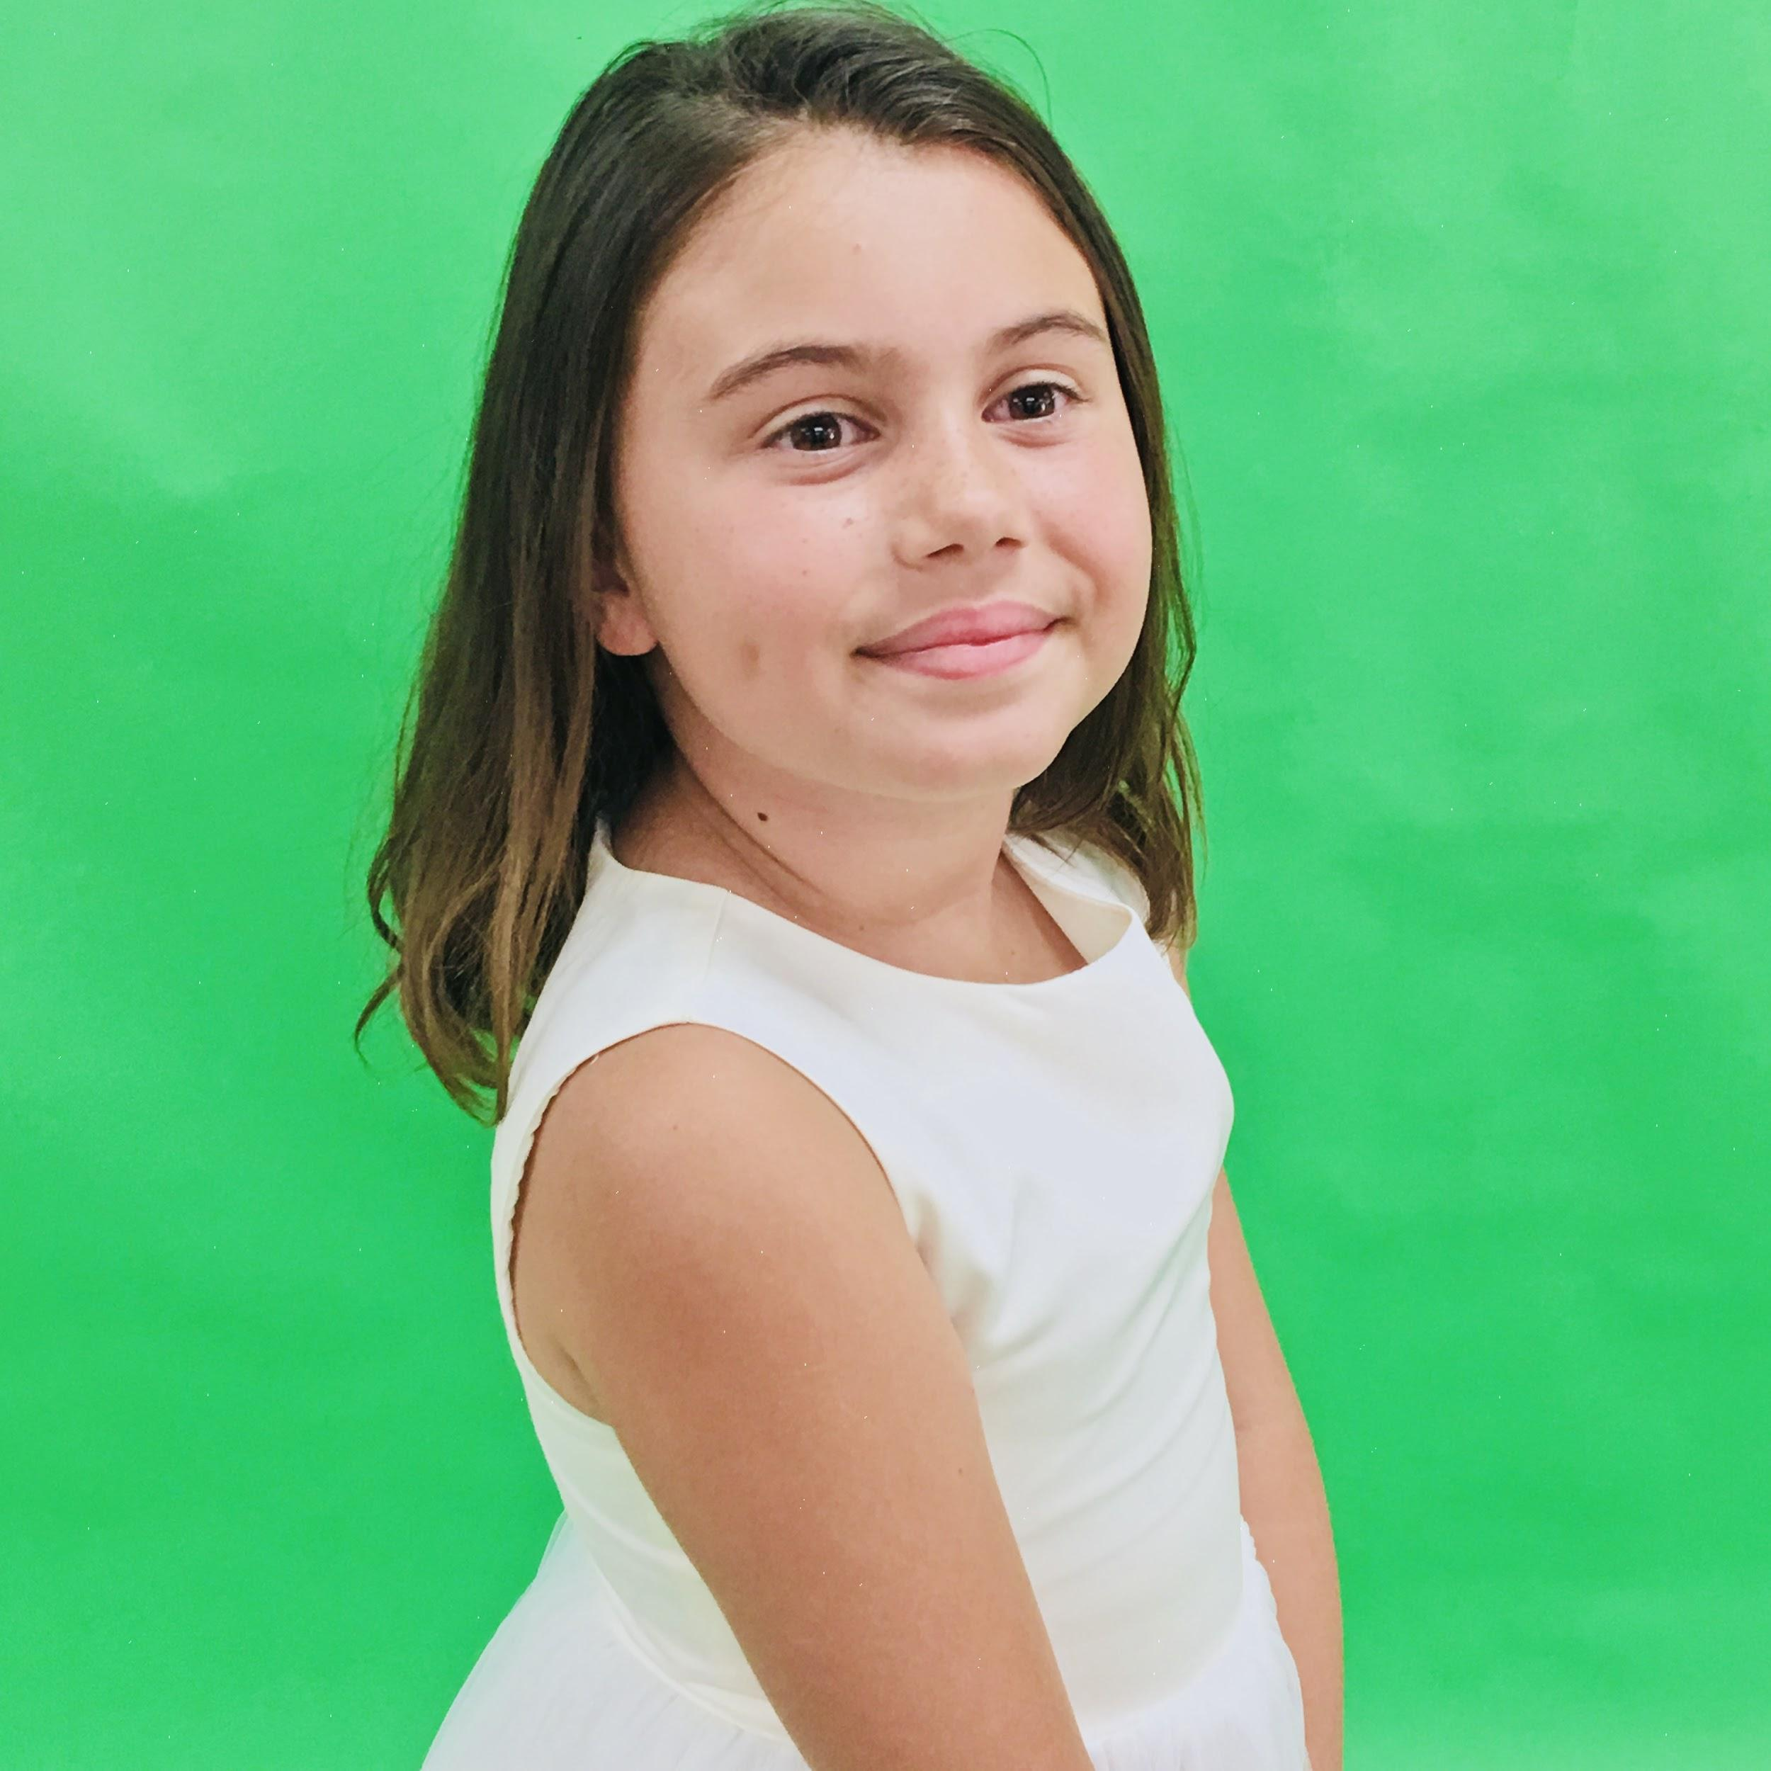

Kailyn Martinez is 8 years old. This is her Third SDCAP production she was Small Alice, in Alice in Wonderland Rebooted, Aladdin Rebooted, and in Peter Pan Rebooted she is playing MoonGlow the Mermaid and Nana the Dog. In her spare time when not Dancing, Singing and Acting she loves to go to the beach with HONEY her puppy. Kailyn is a Beautiful, Sweet and Talented little girl we are so proud for her.

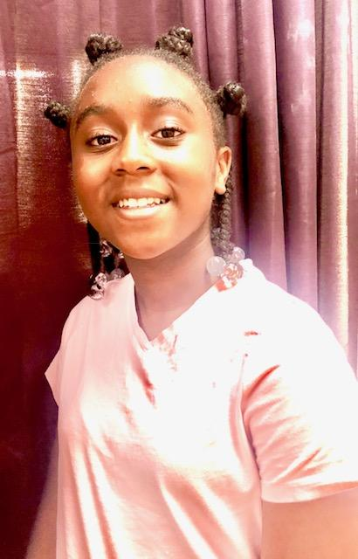

**Jayden Dial** *Mrs. Darling, Crocodile*

Jayden Dial is a dancer, singer and writer. She has been very engaged in the arts since a very young age-her first performance was at age two, at the School for Creative and Performing Arts. She currently performs with Expressions of Praise dance ensemble as a soloist. Past productions include, “**Hoka Poka,**” and the “**Wizard of Oz**” as Dorothy. In 2017, as a guest artist with the Bk Soul ensemble in their production of “**Lioness”** for San Diego Fringe Festival. Jayden is an enthusiastic and passionate reader and writer. She was the writer for a production of “**The Emperor**” and sole writer for an adaptation of “**Julius Caesar,** at her school. Some of favorite things to do are read, eat and design fashion. She continues to explore her gifts and hopes to find ways to build and connect.

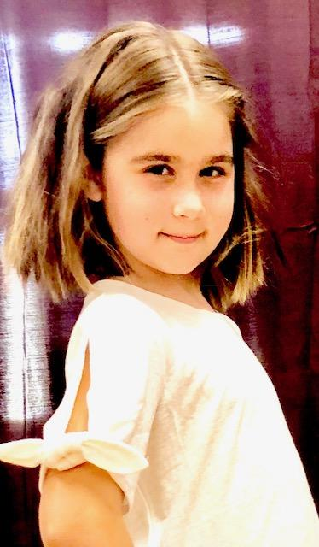

**Claire Palmer** *Nibs/Pearl*

Claire Palmer is an 8-year-old and is going in the Dual Language Spanish Immersion 2nd grade class at Adams Elementary. This is her 8th show with SDCAP. When Claire is not performing, she loves to do art, play with her cats, cook and create and swim. Her favorite musicals are Godspell and Annie. Claire has performed in Wizard of Oz, Jungle Book, Cinderella Rebooted, Aladdin Rebooted and starred in Tacky the Penguin all with SDCAP.



**Molly Palmer** *Curly/Anemone*

Molly Palmer is a 6-year-old and is going into the Dual Language Spanish Immersion 1st grade class at Adams Elementary. When Molly is not performing, she is a maker and thinker and creates many things in the kitchen and at her Lego table. She loves painting, snuggling and reading comics and aspires to be a scientist when she grows up. She likes Annie and the stage production of Little Mermaid. She has been in 6 performances with SDCAP including many dance performances, Cinderella Rebooted and Aladdin Rebooted.

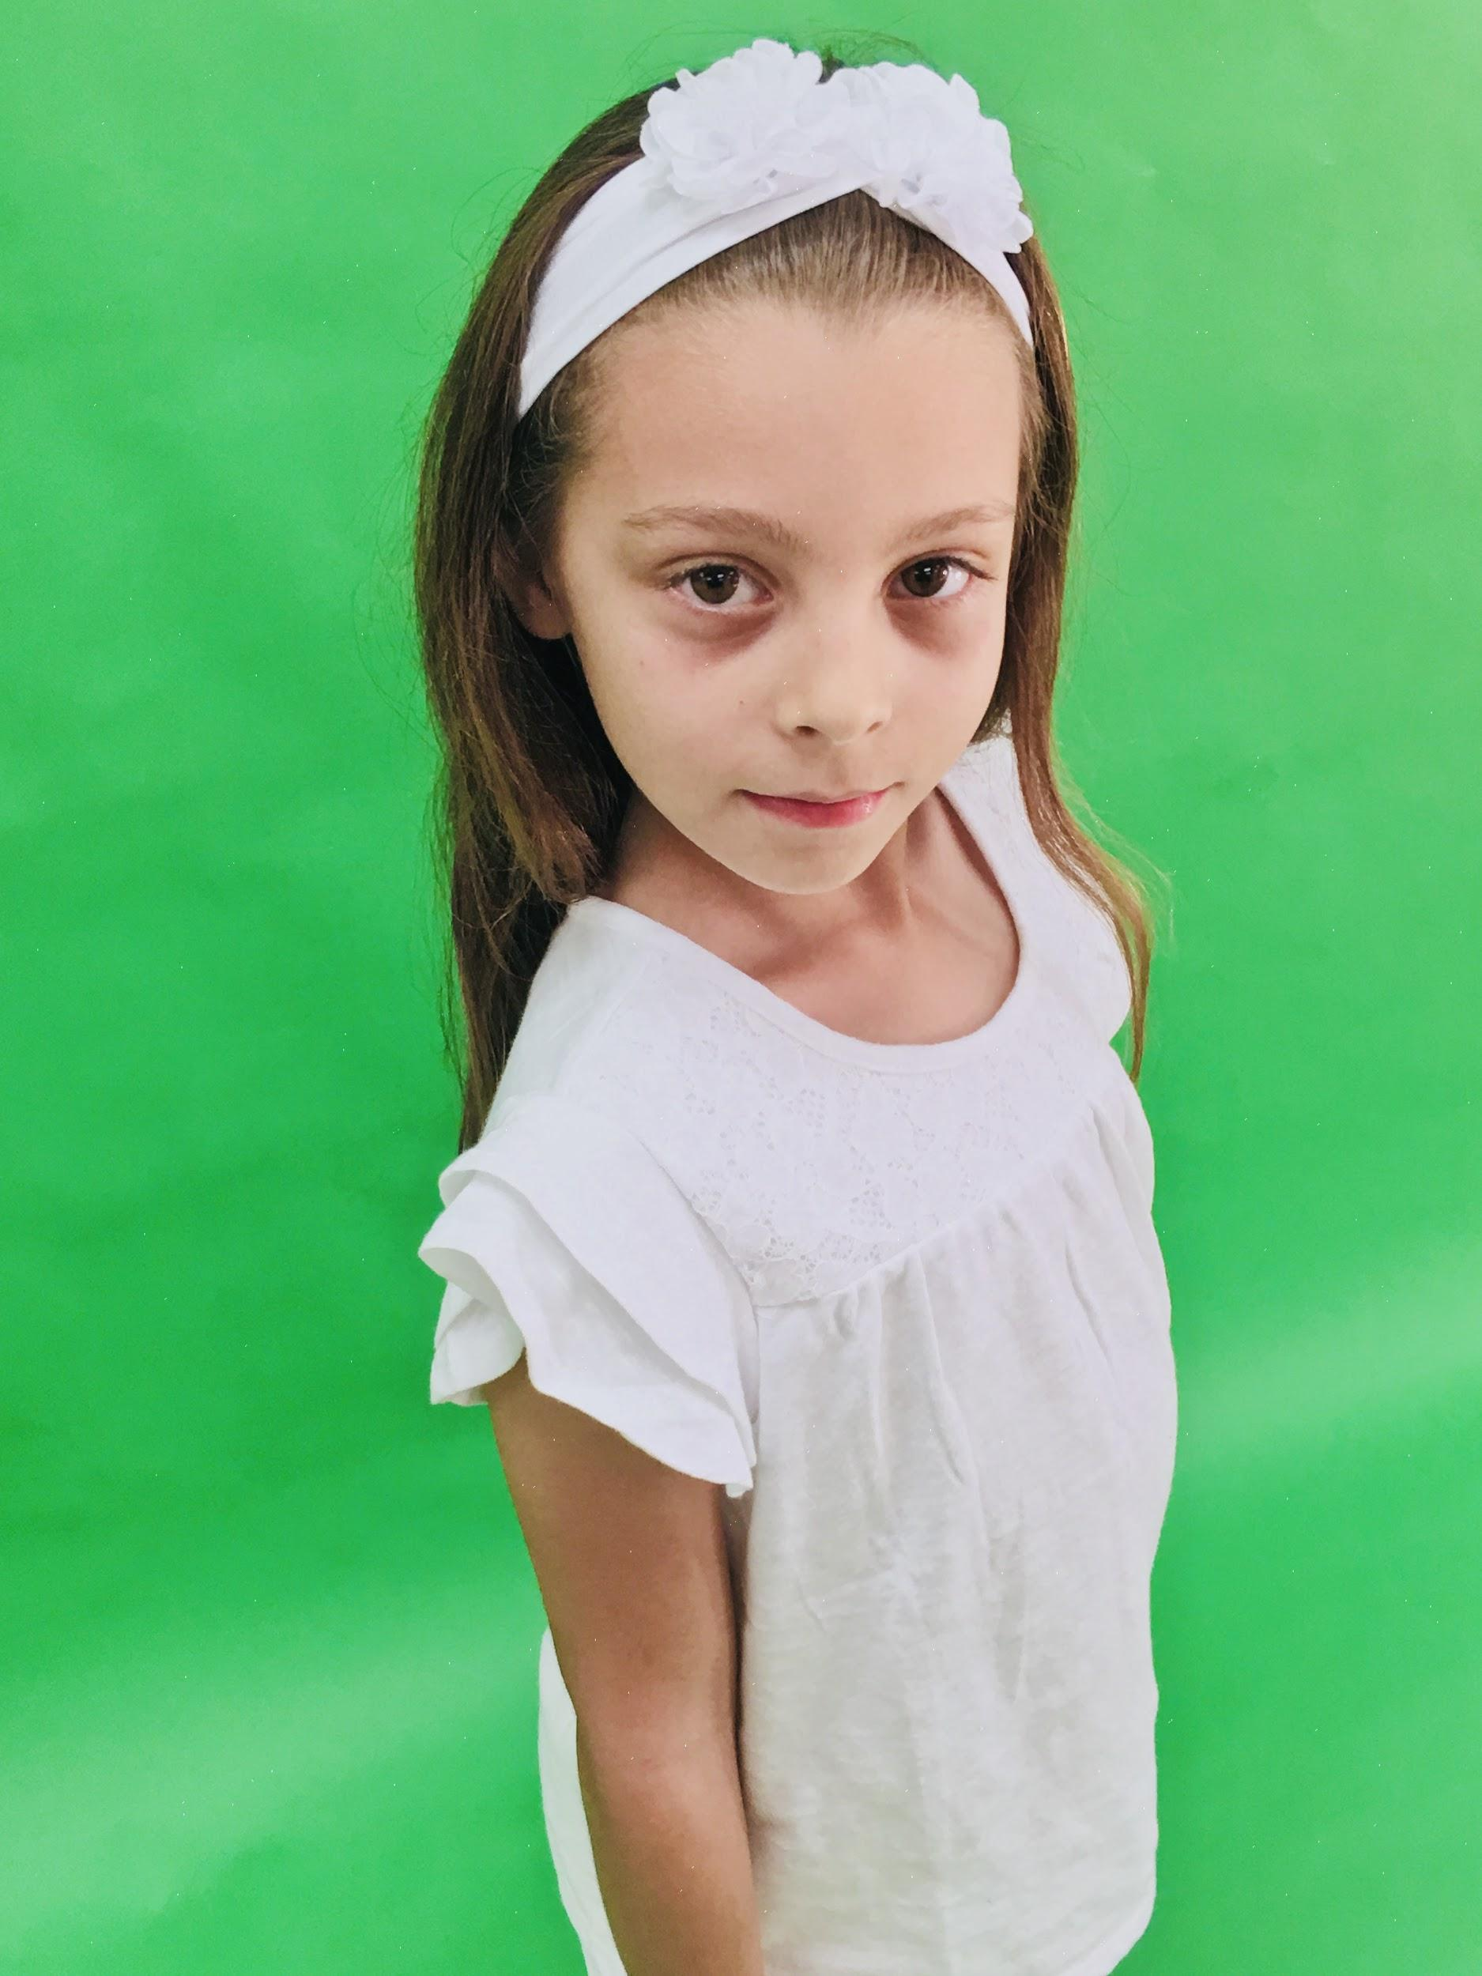

**Layla Hazin** *Tootles/Starfish*

**Pirate Crew (SDCAP Hip Hop class)**

**Pirate crew choreography:**  Mr Dyno

Braydon Litkenhaus Isaac Litkenhaus

Corbin Moriset Petra Moriset

**Shout Outs!!!!**

"Corbin and Petra - We love you so much and we're so proud of you!” Love, Mom and Dad!

“Izze-you never cease to impress, Thank you for stepping in and Rocking it!” Love Mom

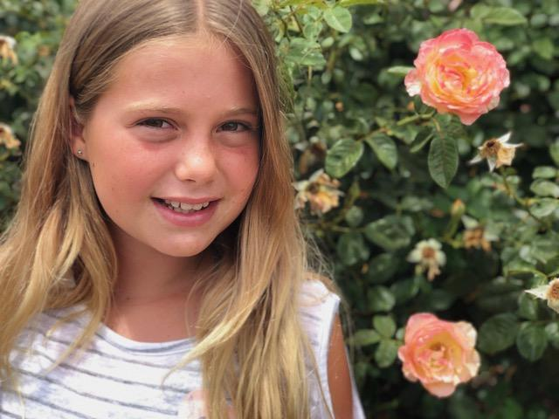

Dear Tahlia Dean,

We are so excited to watch you shine in the role of Tinkerbell. Break a leg!!

All our love, Mama, Papa, Evelyn, June and Josie

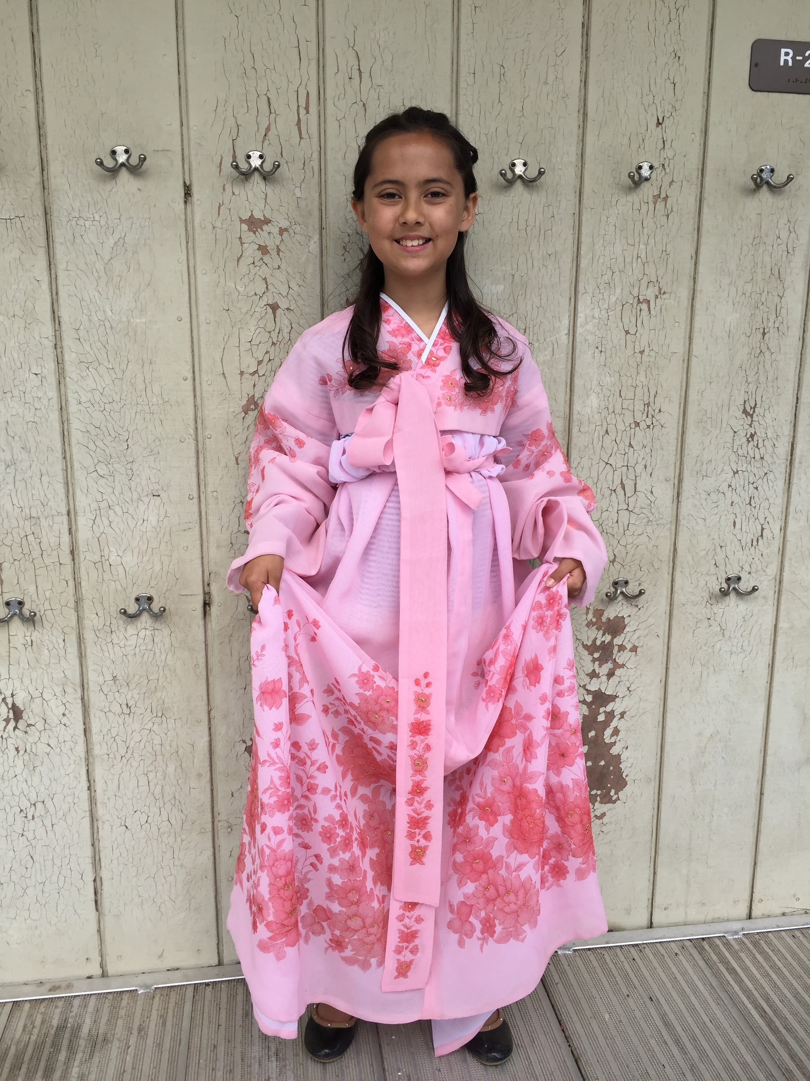

Congratulations, Cassidy, on your first role in a theater production! It has been a joy to see your skills grow with Coach Tammy and Ms.Laura! The whole family is very proud of you! We hope this is the first of many productions.

Love always, Dad, Mom, Alexa, Ruby and Freckles





**Thank you to all of the Cast, Families, Friends, OB Playhouse, and everyone who contributed their time to making this production come to life!!!**

**SAN DIEGO CREATIVE ARTS PROJECT**

**"Where Arts Emerge”**

San Diego Creative Arts Project, SDCAP, isSouthern California's hot spot for Professionally Directed Youth Theatre, Conservatory Classes in Dance, Voice, Theatre, Media Arts, and Fitness Training. Studios are located in the University/Normal Heights neighborhood, on 30th off Adams Avenue, SDCAP is a 501c3 Non Profit Performing Arts organization invested in engaging, training, and inspiring students of all ages and backgrounds who desire to grow artistically and confidently in the performing arts. By offering classes, camps, and performance opportunities for kids and adults, SDCAP aims to inspire creativity and create a positive impact on bringing arts to the community. Our organization is committed to providing an ongoing presence in the community, granting access to the arts as well as consistent after-school activity for children, including those who might not otherwise be able to afford it.

Formed in 2014, SDCAP has a studio for classes and rehearsals and forged partnerships with San Diego Symphony, San Diego Repertory Theatre, Academy of Our Lady of Peace, and other schools. Under the Direction of Laura Hodge, SDCAP has performed in many local parades and special events, appeared several times on Channel 8 News, Channel 5, and KUSI. Some main stage productions include *Godspell*, *The Wizard of Oz*, *Beauty and the Beast*, *Seussical*, *Fame,* and many more...

Most recently SDCAP has been producing the “Rebooted” Series of original scripts written by Executive Artistic Director, Laura Hodge for SDCAP, with productions in San Diego, Rosarito, and Tijuana, BC. These script are new, updated versions of old classics with rock/pop songs from the ‘80’s & ‘90s to the present. These colorful, unique Rebooted scripts include Cinderella, Alice, Aladdin, and now - Peter Pan Rebooted.

A program in the performing arts fosters a strong technical foundation as well as emotional maturity and valuable interpersonal skills. Our goal is to provide an entrance to the arts to both youth and adults in our community and deliver ongoing support in mastering the performing arts. Local youth involved in our program develop important social ties and participate in creating and maintaining a safe space for themselves and their peers. Friendships and skills developed here will last a lifetime.

DONATIONS are Tax Deductible

FEIN: 46-3420810

SAN DIEGO CREATIVE ARTS PROJECT

4715 30th Street Suite 4, SD, CA 92116

[sdcreativearts@gmail.com](mailto:sdcreativearts@gmail.com)

[www.sdcreativeartsproject.org](http://www.sdcreativeartsproject.org)

619-786-7523





**FALL REGISTRATION at SDCAP!!!!**

Classes for Kids and Adults

Dance, Voice, Acting, Fitness, Salsa, Belly Dance, Pilates, Yoga, private coaching, and more...

August 28, 30: 4-6 pm, or by appointment.

**AUDITIONS!!!!**

**Annie**

September 4, 6, & 8~ By appointment

Prepare a one minute monologue, and upbeat song.

**San Diego Creative Arts Project**

**4715 30th Street, Suite 4, 92116**

sdcreativearts@gmail.com

619-786-0523

www.sdcreativeartsproject.org

